***MYSQL PROJECT***

Q1. Write a query on products and their corresponding orders, and arrange them in chronological order based on the order date?

ANS. select * from products,orders where products.id = orders.id order by order_date;

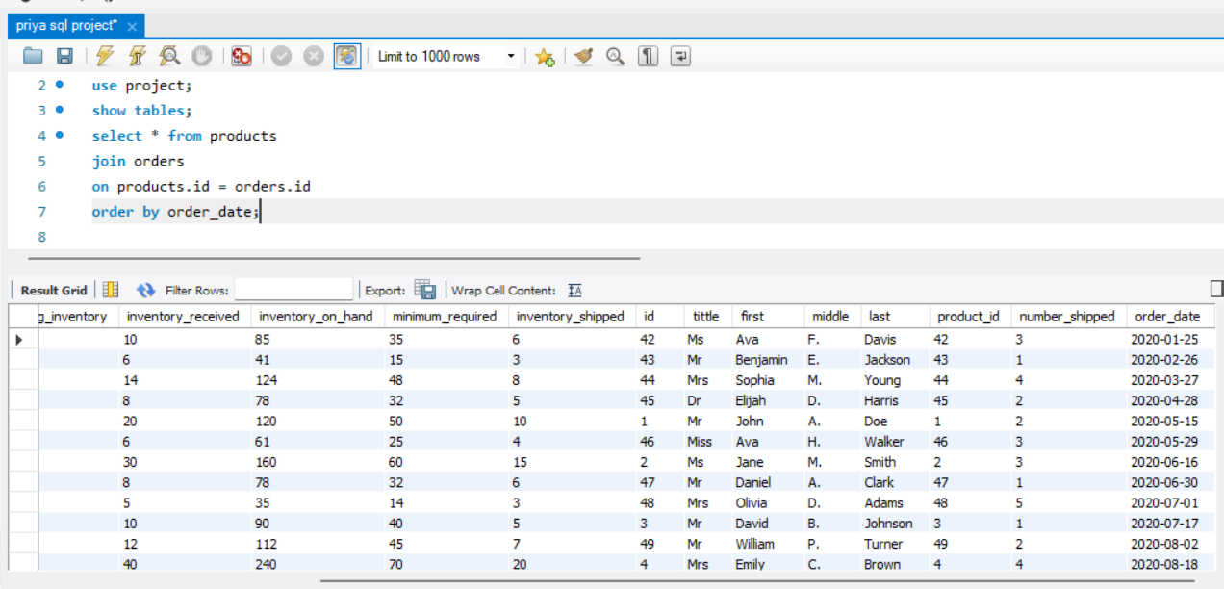

Q2. Write down the query for the first, middle, and last names of customers, along with the order ID, product name, and the number of items shipped for each order in descending order

select first,middle,last,orders.id,product_name,number_shipped

from products

join orders

on products.id = orders.id

order by number_shipped desc;

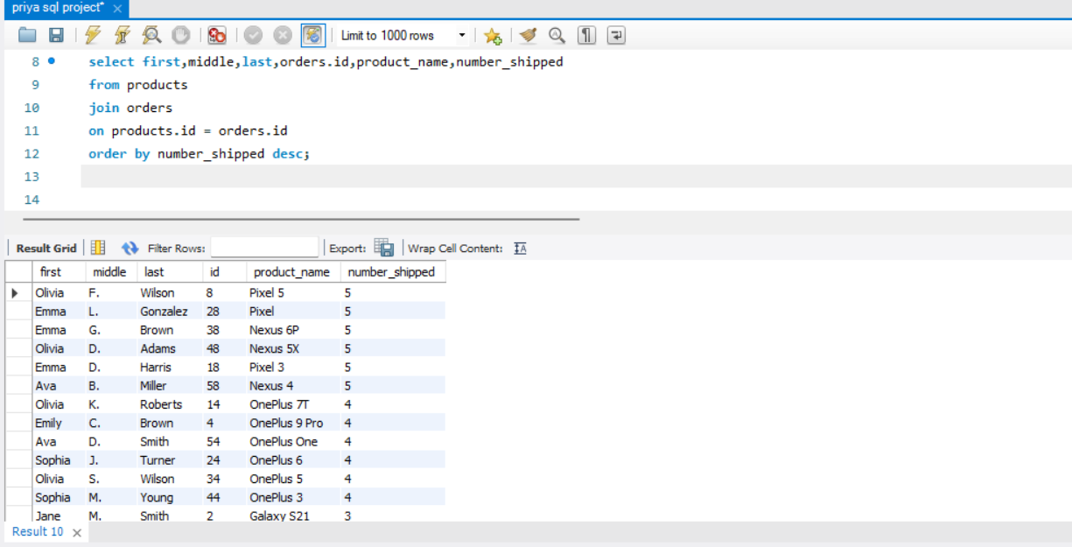

Q3. Write the query for product labels, part numbers, and minimum required quantities for orders where the minimum required quantity is less than 50?"

Ans

select product_label,part_number,minimum_required,orders.id

from products

join orders

on products.id = orders.id

order by minimum_required <50;

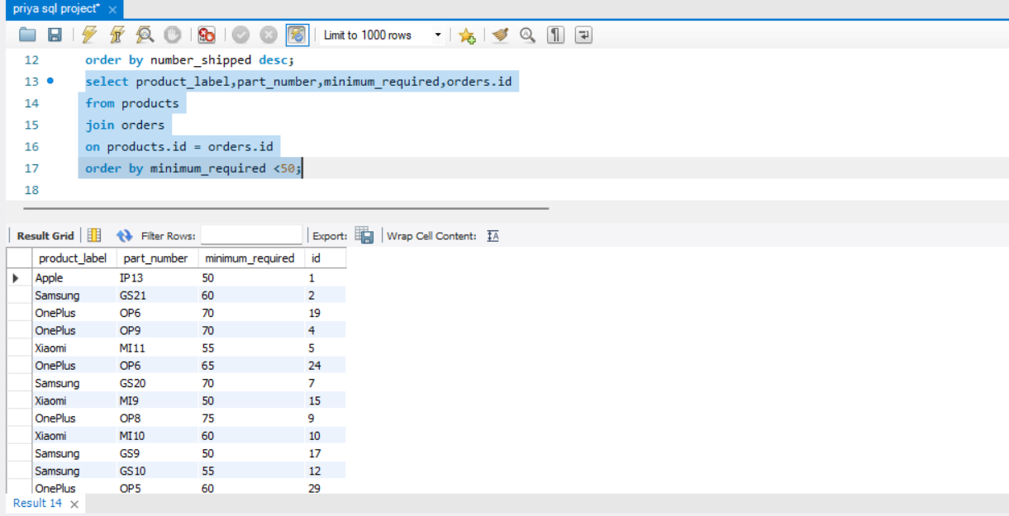

Q4. Write the query for products and orders, between 2020 and 2022 be arranged in an order of when the orders were place and the quantity of orders shipped.

Ans. select product_name,first,last ,number_shipped ,order_date

from products

join orders

on products.id = orders.id

where year(order_date) between 2020 and 2022

order by order_date;

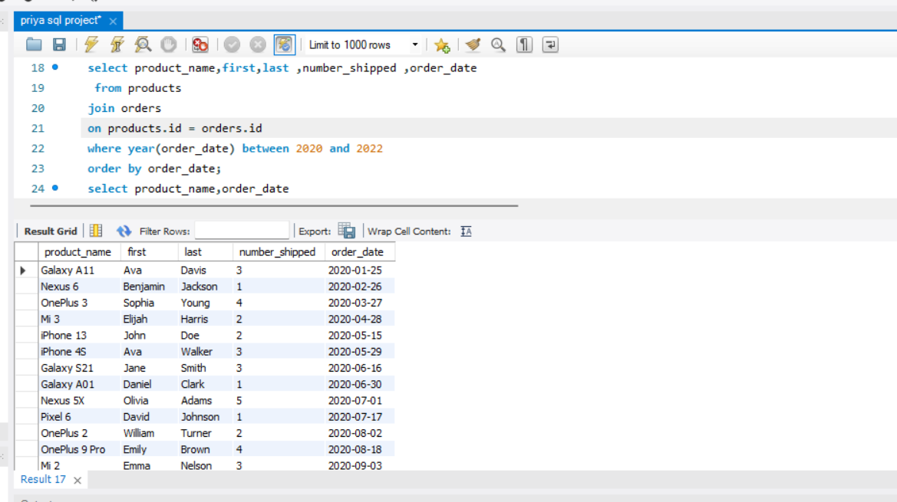

Q5.write the query for how many orders were placed each year, and list these numbers from the most recent year to the oldest year?"

Ans.

SELECT YEAR(order_date) AS order_year, COUNT(*) AS order_count

FROM products

join orders

on products.id = orders.id

GROUP BY order_year

ORDER BY order_year desc;

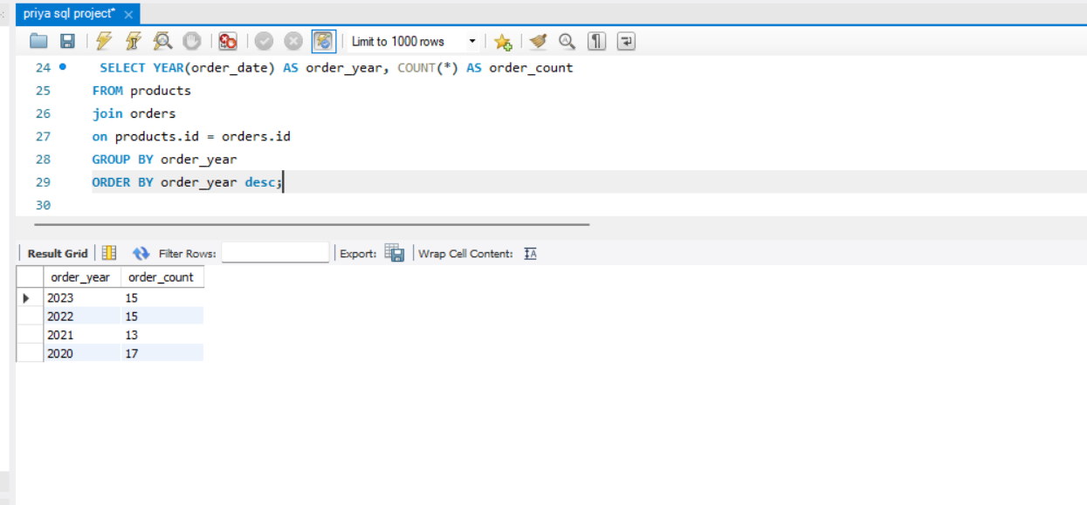

6. write the query for all the information from purchases and their corresponding suppliers arrange this data by product ID in ascending order

Ans -select * from purchases

join suppliers

on purchases.supplier_id=suppliers.id

order by product_id;

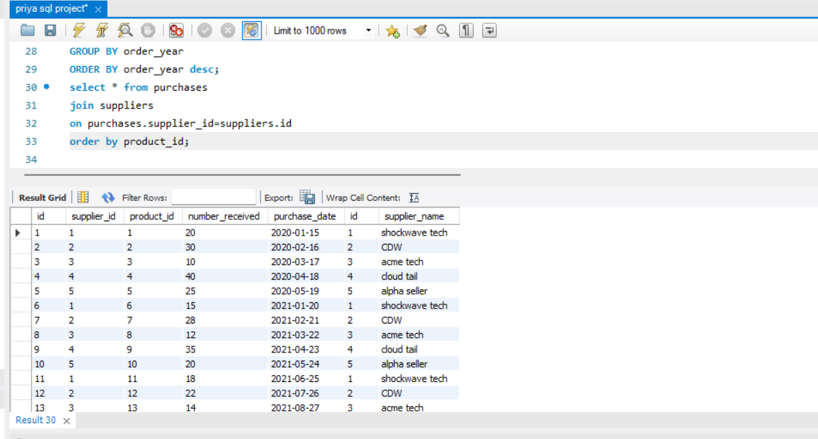

Q7. Write the query for the quantity received, supplier names, and product IDs for purchases, and sort them by product ID?"

Ans. select number_received,supplier_name,product_id

from purchases

join suppliers

on purchases.supplier_id=suppliers.id

order by product_id;

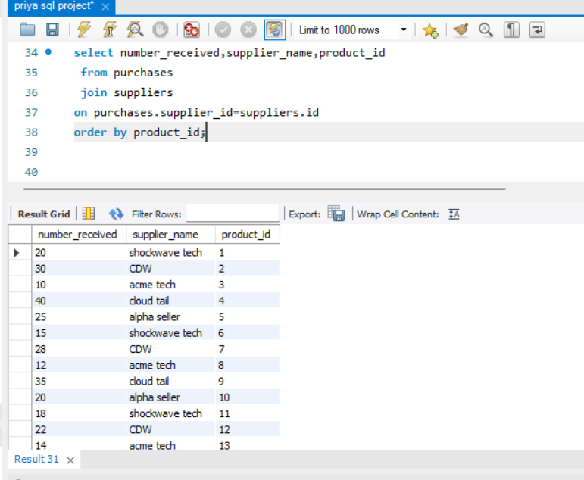

Q8. Write down the query for supplier names and the total quantities received for purchases from each supplier and arrange this information from the highest total quantity to the lowest

Ans. SELECT supplier_name, SUM(number_received) AS total_purchase

FROM purchases

JOIN suppliers

on purchases.supplier_id=suppliers.id

GROUP BY supplier_name

ORDER BY total_purchase desc;

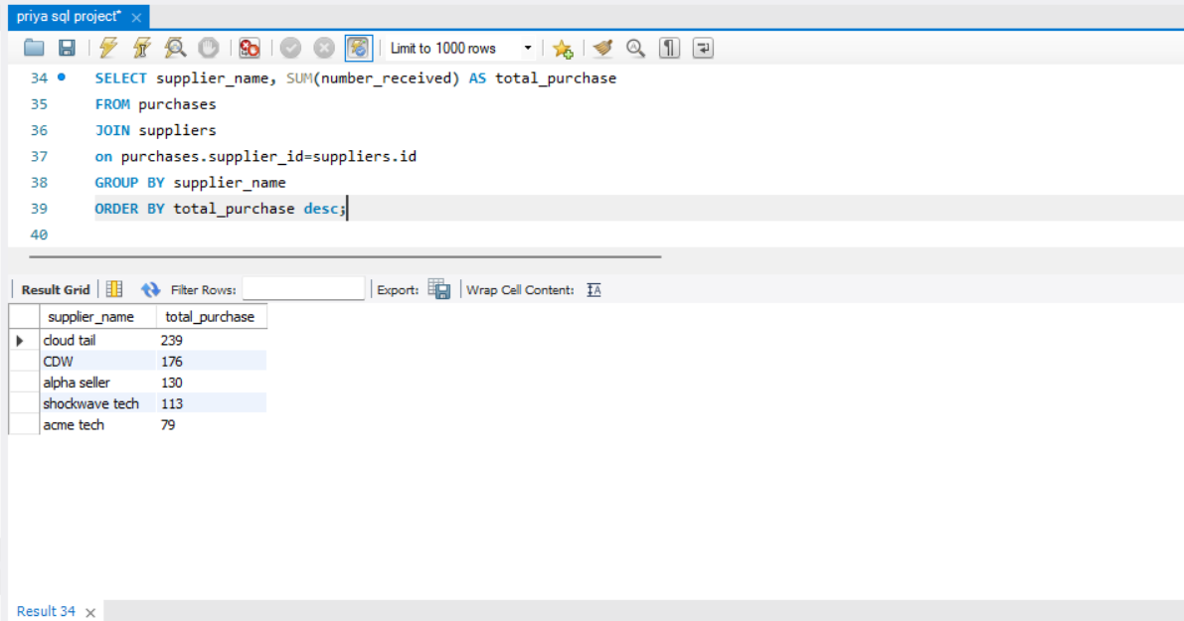

Q9. Write the query for How much was received from suppliers each year, and list these totals from the most recent year to the oldest year

Ans. SELECT YEAR(purchase_date) AS purchase_year, SUM(number_received) AS total_received

FROM purchases

join suppliers

on purchases.supplier_id=suppliers.id

GROUP BY purchase_year

ORDER BY purchase_year desc;

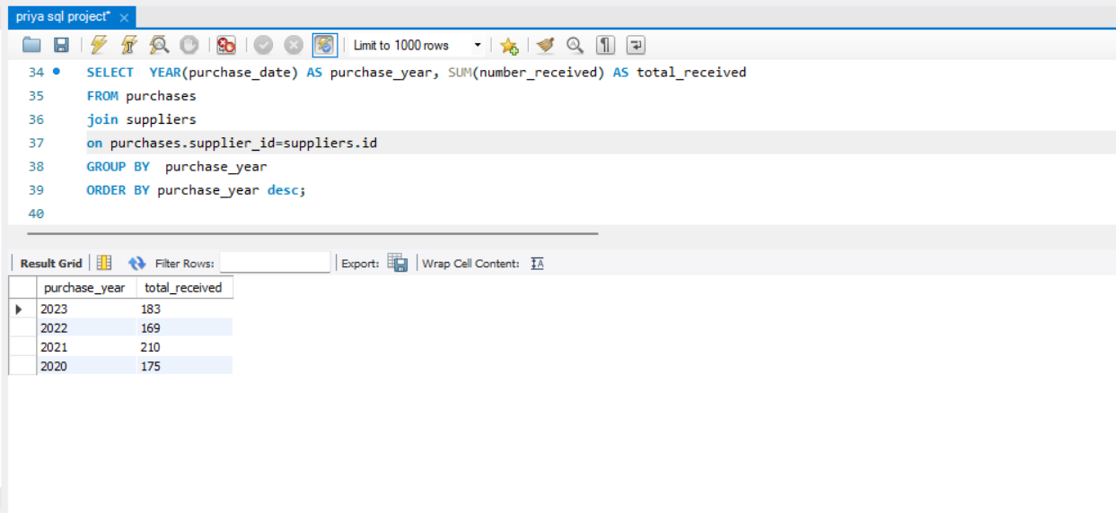

Q10.write the query for the supplier names, purchase years, and the total quantities received while specifying a specific sorting order: by year first and within each year by supplier name.

Ans -SELECT supplier_name, YEAR(purchase_date) AS purchase_year, SUM(number_received) AS total_received

FROM suppliers

LEFT JOIN purchases on purchases.supplier_id=suppliers.id

GROUP BY supplier_name, purchase_year

ORDER BY purchase_year, supplier_name;

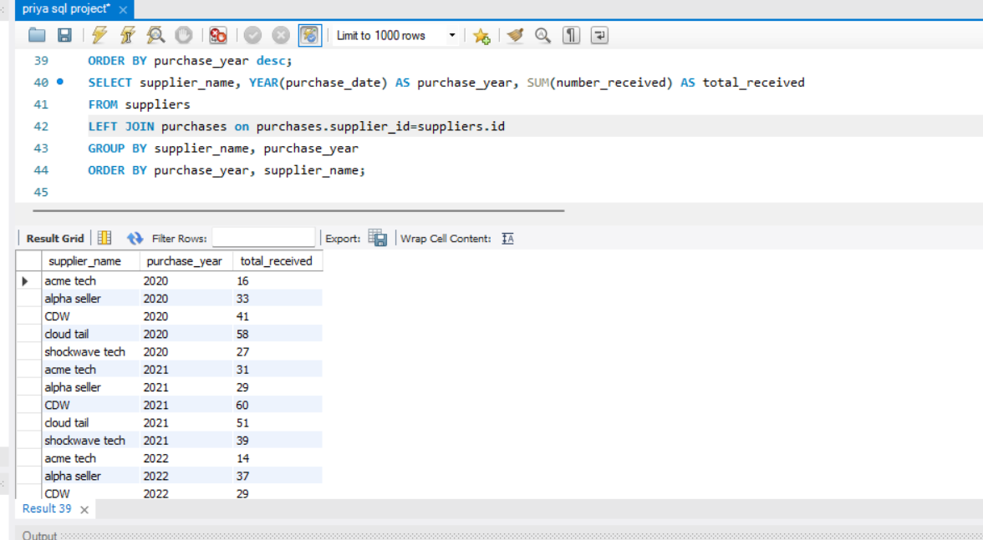

Q11. Write the query to identify the suppliers who haven't supplied any products

Ans. SELECT supplier_name

FROM suppliers

LEFT JOIN purchases on purchases.supplier_id=suppliers.id

WHERE product_id IS NULL;

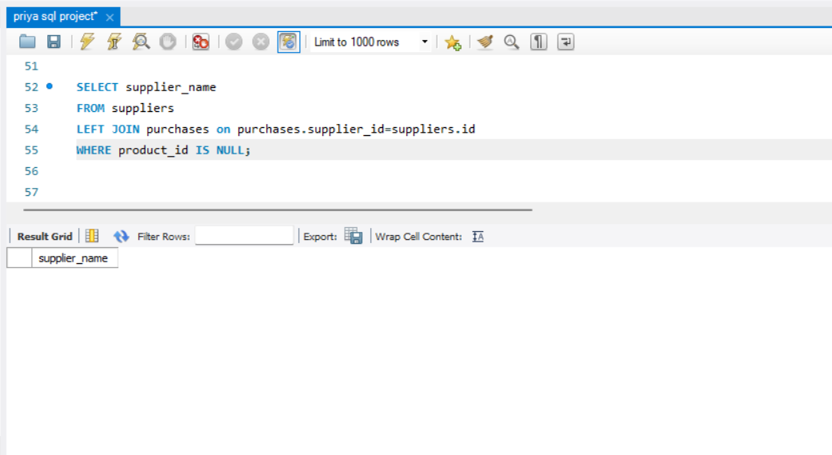

Q12. Write the query to identify the suppliers with the highest and lowest total quantities received and requests the values of these maximum and minimum quantities.

Ans SELECT supplier_name, SUM(number_received) AS total_received

FROM suppliers

LEFT JOIN purchases on purchases.supplier_id=suppliers.id

GROUP BY supplier_name

HAVING total_received = (SELECT MAX(total_received) FROM (SELECT SUM(number_received) AS total_received FROM purchases GROUP BY supplier_id) max_total)

or total_received = (SELECT MIN(total_received) FROM (SELECT SUM(number_received) AS total_received FROM purchases GROUP BY supplier_id) min_total);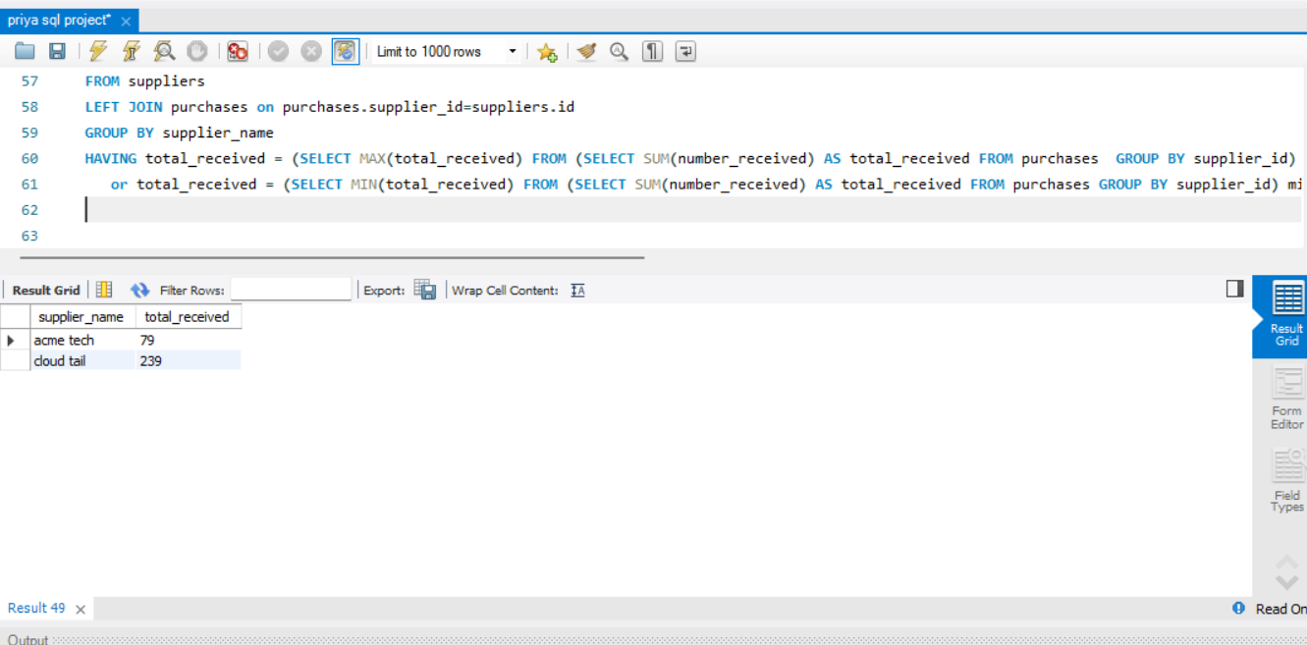

Q13. Write the query to show the quantities received for each product, and list them in descending order with their product names.

Ans. SELECT number_received, product_name

FROM purchases

JOIN products ON purchases.id = products.id

order by number_received desc;

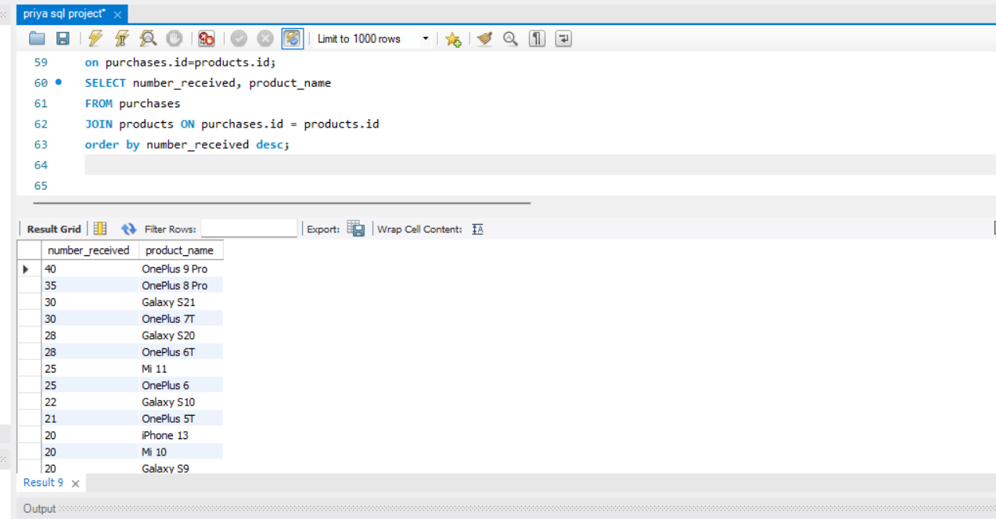

Q14. Write the query for products received the highest total quantity, and list these products along with their total received quantities.

Ans. SELECT product_name, SUM(number_received) AS total_received

FROM products

LEFT JOIN purchases ON products.id = purchases.id

GROUP BY product_name

ORDER BY total_received DESC;

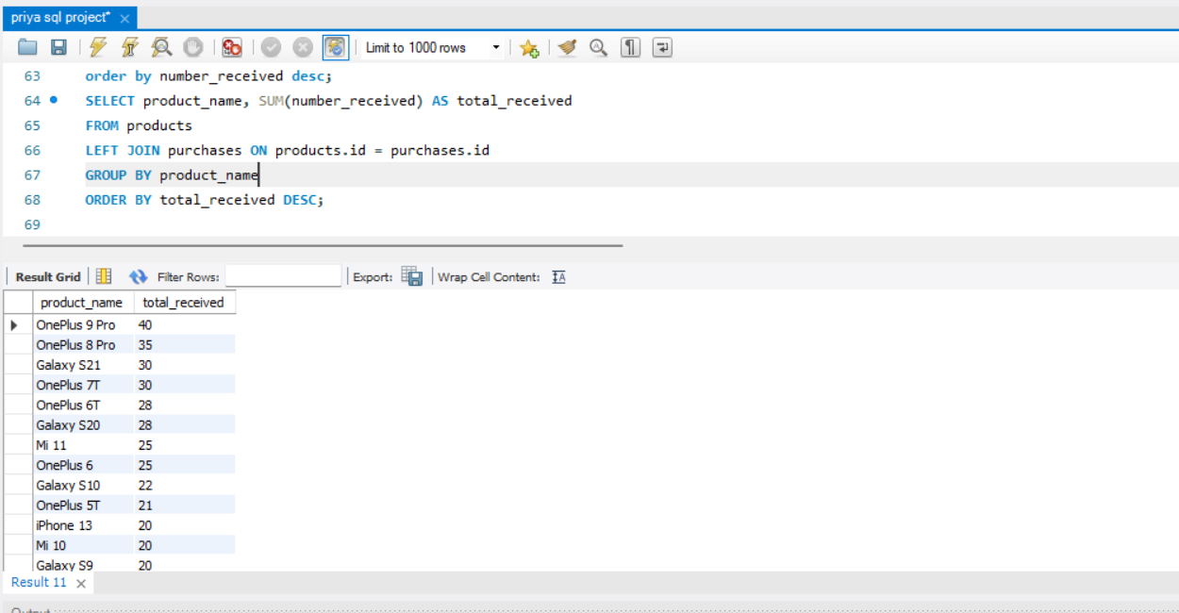

Q15. Write down the query for the average quantity received for each product.

Ans. SELECT product_name, AVG(number_received) AS average_received

FROM products

LEFT JOIN purchases ON products.id = purchases.id

GROUP BY product_name;

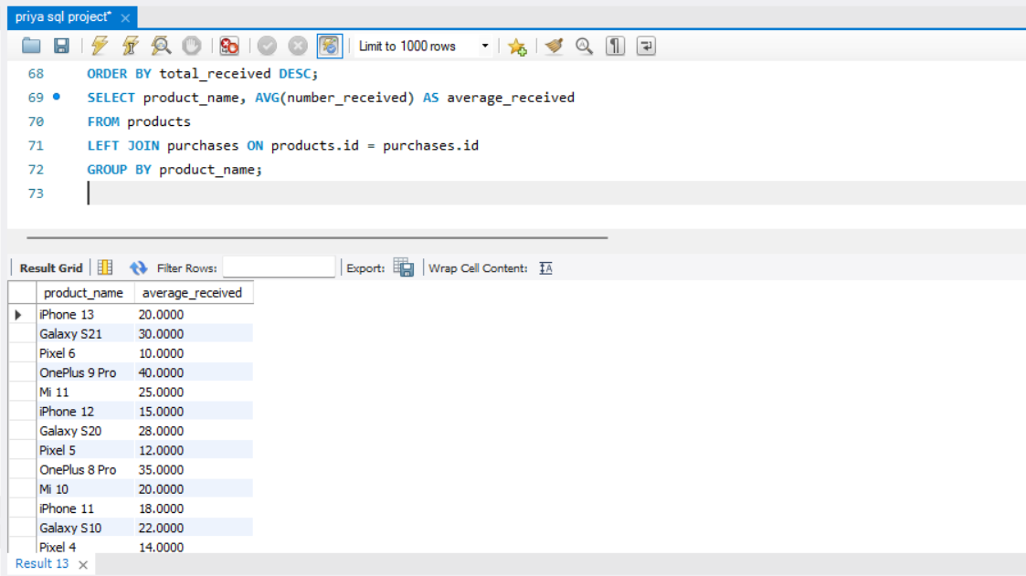

Q16. Write the query to calculate the maximum, minimum, average, and total starting inventory for each product in the "products" table and provides the corresponding statistics .

Ans. SELECT

MAX(starting_inventory) AS max_inventory,

MIN(starting_inventory) AS min_inventory,

AVG(starting_inventory) AS avg_inventory,

SUM(starting_inventory) AS total_inventory,

product_name

FROM products

GROUP BY product_name;

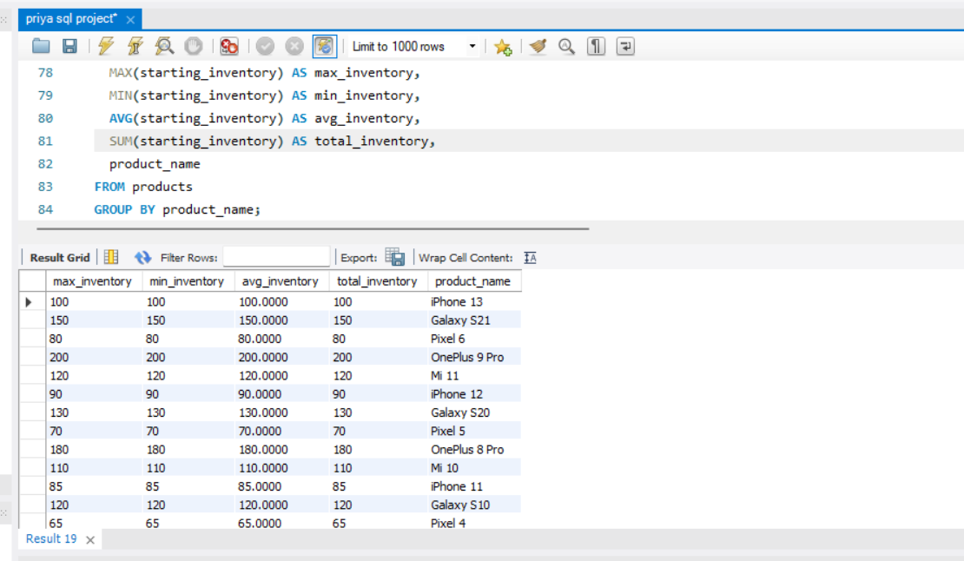

Q17. Write the query to calculate the total number received for each product in the specified year (2023).

Ans. SELECT product_id,

YEAR(purchase_date) AS purchase_year,

SUM(number_received) AS total_received_in_year

FROM purchases

WHERE YEAR(purchase_date) = 2023

GROUP BY product_id, purchase_year;

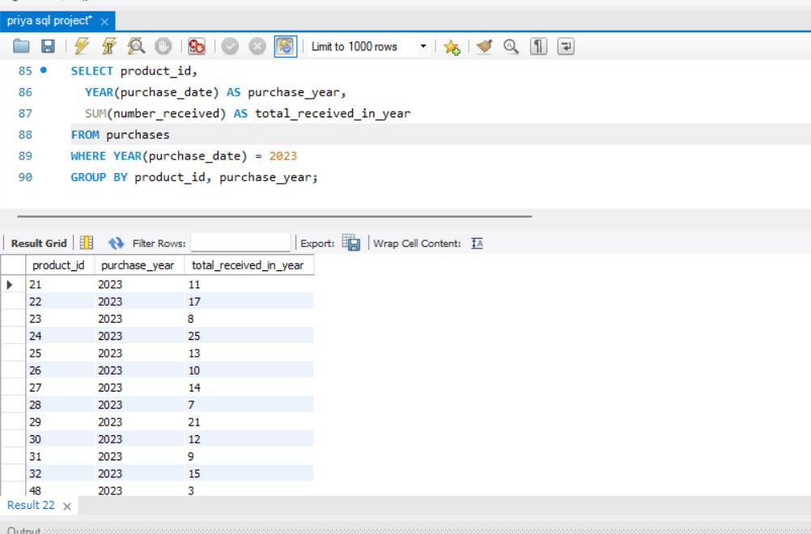

Q18. Write the query to show the orders, along with customer first and last names, that were placed between January 1, 2022, and December 31, 2022

Ans. SELECT order_date,first,last

FROM orders

WHERE order_date BETWEEN '2022-01-01' AND '2022-12-31';

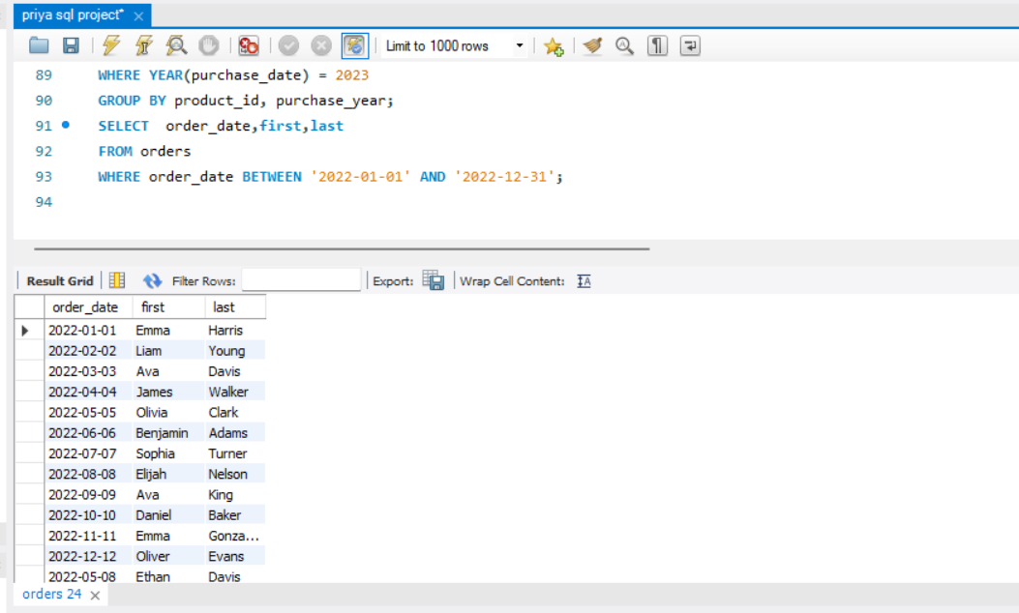

Q19. Write the query for the names and labels of products that contain the word 'phone' in their name."

SELECT product_name ,product_label

FROM products

WHERE product_name LIKE '%phone%';

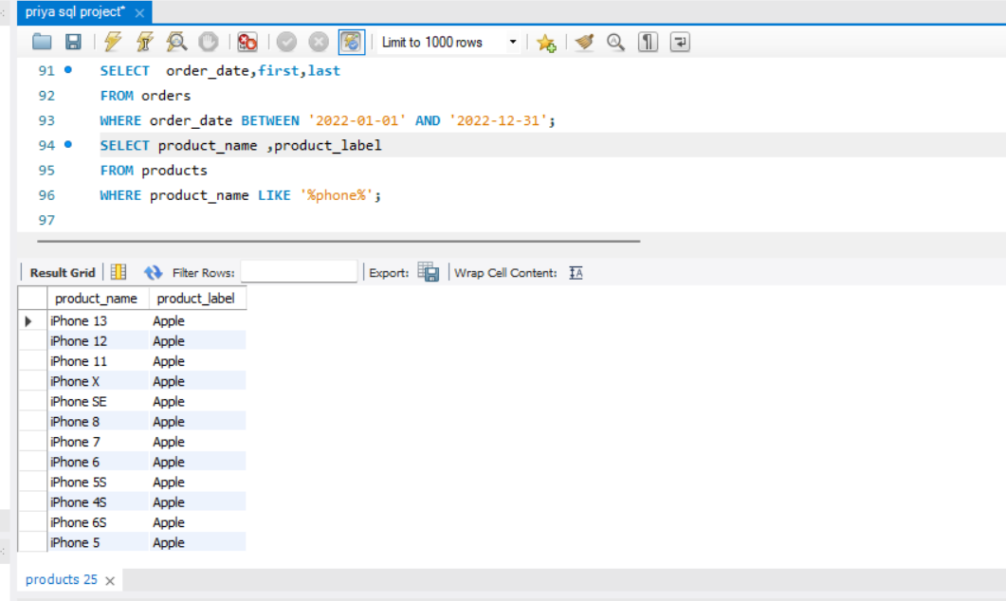

Q20. Write the query to Show 10 orders, starting from the 21st order in the list.

Ans. SELECT *

FROM orders

LIMIT 10

OFFSET 20;

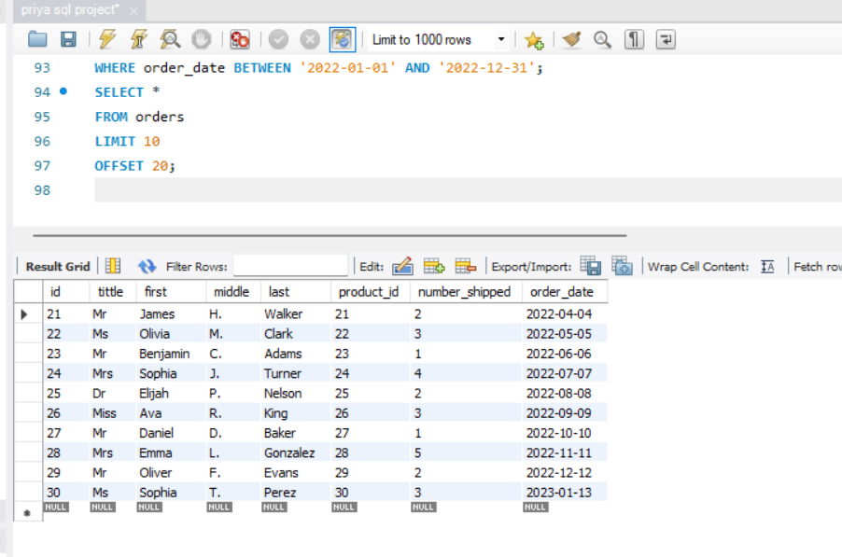

Q21. Write the query for suppliers which have received a total quantity of items greater than 100, and show the supplier IDs along with their respective total received quantities.

Ans. SELECT supplier_id, SUM(number_received) AS total_received

FROM purchases

GROUP BY supplier_id

HAVING total_received > 100;

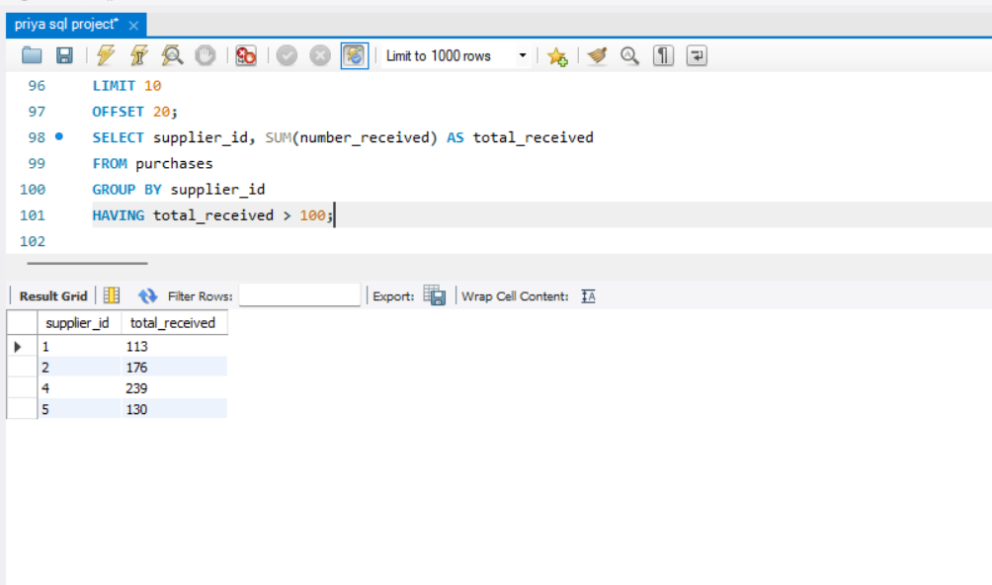

Q22. Write the query to list the product names, inventory on hand, and minimum required quantities for products where the inventory on hand is greater than 50 or less than the minimum required."

SELECT product_name, inventory_on_hand, minimum_required

FROM products

WHERE inventory_on_hand >50 OR inventory_on_hand < minimum_required;

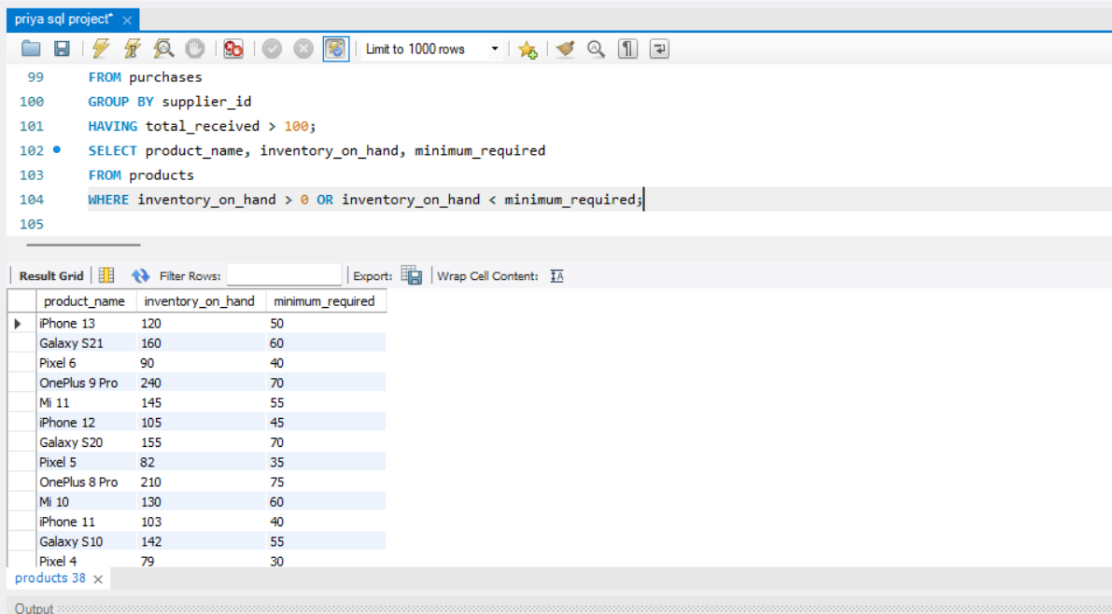

Q23. Write the query for product names that include the word 'pro' in a case-insensitive manner.

Ans. SELECT product_name

FROM products

WHERE LOWER(product_name) LIKE '%pro%';

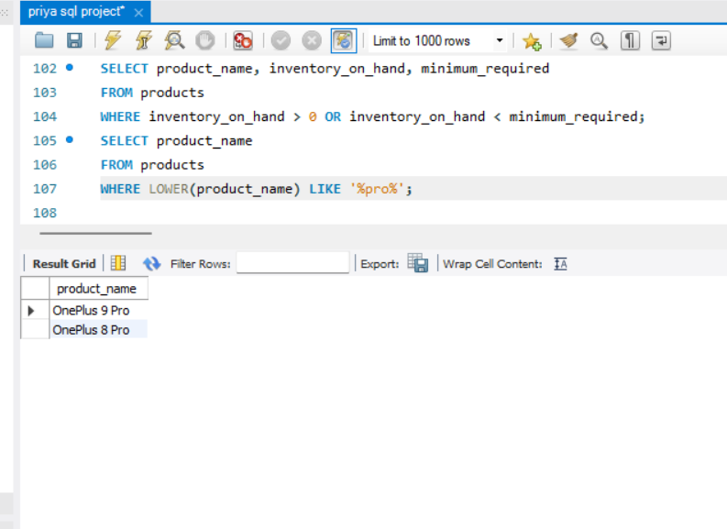

Q24 Write the query To find products with starting inventory within a specific range between 50 and 100

Ans. SELECT product_name, starting_inventory

FROM products

WHERE starting_inventory BETWEEN 50 AND 100

order by starting_inventory desc;

